**Experiment 5**

**Aim:** Write a shell script to add user and password on a Linux System

**Software:** Ubuntu

**Procedure:**

* Get superusers access using sudo su
* Using command #gedit create a .sh file
* Enter the following Shell Script

echo enter username

read username

echo enter password

read password

pass=$(perl -e 'print crypt($ARGV[1], "password")' $password)

useradd -p"$pass" "username"

echo username created

echo $pass

* Use commands #chmod +x doc.sh
* Then ./doc.sh

**Output:**

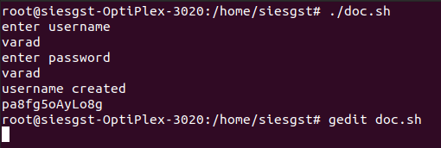

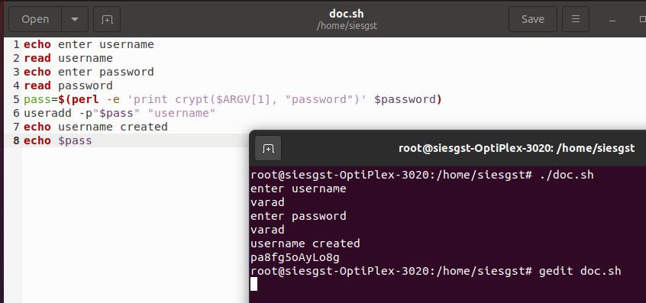

**Conclusion:**

Successfully created a shell script to add users and passwords, this can save time and ensure consistency on a Linux system.